Majd Haddad

Assignment 6

11/30/22

Professor Grinberg

/\*

\* Class: CMSC203

\* Instructor: Professor Grinberg

\* Description: Creating a order of beverages program.

\* Due: 12/05/22

\* Platform/compiler: Eclipse

\* I pledge that I have completed the programming

\* assignment independently. I have not copied the code

\* from a student or any source. I have not given my code

\* to any student.

Print your Name here: Majd Haddad

\*/

UML Diagram:

AlcoholTestStudent JUNIT Screenshot:

BevShopDriverApp Screenshots (required and sample):

Sample:

Required:

BevShopTestStudent Junit Screenshot:

CoffeeTestStudent Junit Screenshot:

CustomerTestStudent Junit screenshot:

DayTestStudent Junit Screenshot:



OrderTestStudent Junit Screenshot:

SizeTestStudent Junit Screenshot:

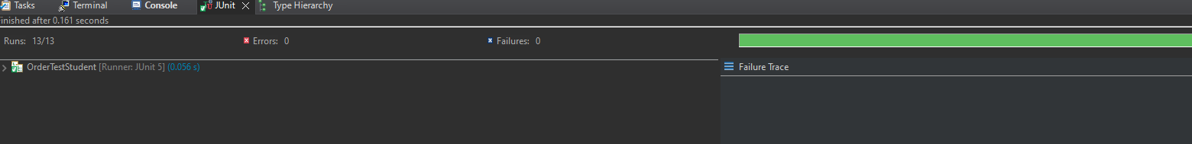

SmoothieTestStudent Junit Screenshot:

TypeTestStudent Junit Screenshot:

Github Screenshot:

Lessons learned:

I learned a lot after this project. I learned more about the Object class and how everything extends it. I also learned more about advanced classes and how each class can relate to another in a different way using inheritance, aggregation, or interface. I learned that you can cast Objects to a Class Object which now makes sense to me. I struggled with Junit as there were a lot of tests to cover for bevShop which was sort of frustrating. I also struggled with how to connect the classes together until I actually played around with the code. In the future, I would probably be more prepared before starting the project even though I was very familiar with every class and sort of knew what I was doing.